Copley-Fairlawn Athletic Association
Tom Dugan
Mobile: 330-714-3568
Field Preparation Notes

Hello. I thought a few helpful hints might be in order for everyone in preparing the fields for the tournament. Some of you are pro’s and others; this may be the first time you are preparing a baseball field.

Dragging
With the exception of the HS Varsity field, all of our fields are completely “Diamond Clay” infields (often referred to as Red Brick). The material is a combination of Sand, calcite clay, silt and other materials. If the field is dry, you MUST drag slowly. The faster you drag a dry field, the more the silt becomes airborne and flies away. The cost of re-dressing a field is in the thousands of dollars, so let’s try and keep as much on the field vs. in the air. Also, making lots of dust in the air while the spectators are sitting in their chairs won’t help making them return customers next year. A moist field is a happy field to drag!

When dragging, start at pitcher’s mound and work in circular patterns out. When you finish, don’t drive the drag and excess material onto the grass. Stop a few feet short; pick up the drag and roll it up and put it on the seat or in between your feet. (NEVER on the hood as the weight presses the hood onto the motor and fan). Also, please don’t drag the drag on the grass – bends it up and collects seeds and grass which end up being deposited on the red brick later. Then, hand rake the excess flat. As you start to drag, someone else can pull the bases and place a feathered plug in the empty sleeve. It is best to do it this way, as the kids tend to push material towards the bases as they slide. If you don’t pull the base and drag completely over the base surface, you won’t be pulling the material back to where it belongs.

Depending on the timing between games on Saturday and Sunday, you may not be able to drag and re-chalk every field. Our objective IS to drag and re-chalk every time, but we also have to keep the games on track. When you have back-to-back games, I suggest you drag a circle around home plate first (allows someone else to start chalking the batters box) and then you can start dragging outwards from the pitchers mound or just re-chalk the batters box and baselines if you are short on time. Most of our drags are 5’x3’ and very light weight. You can easily hand drag them in key spots in between games like the Indians do.

Water
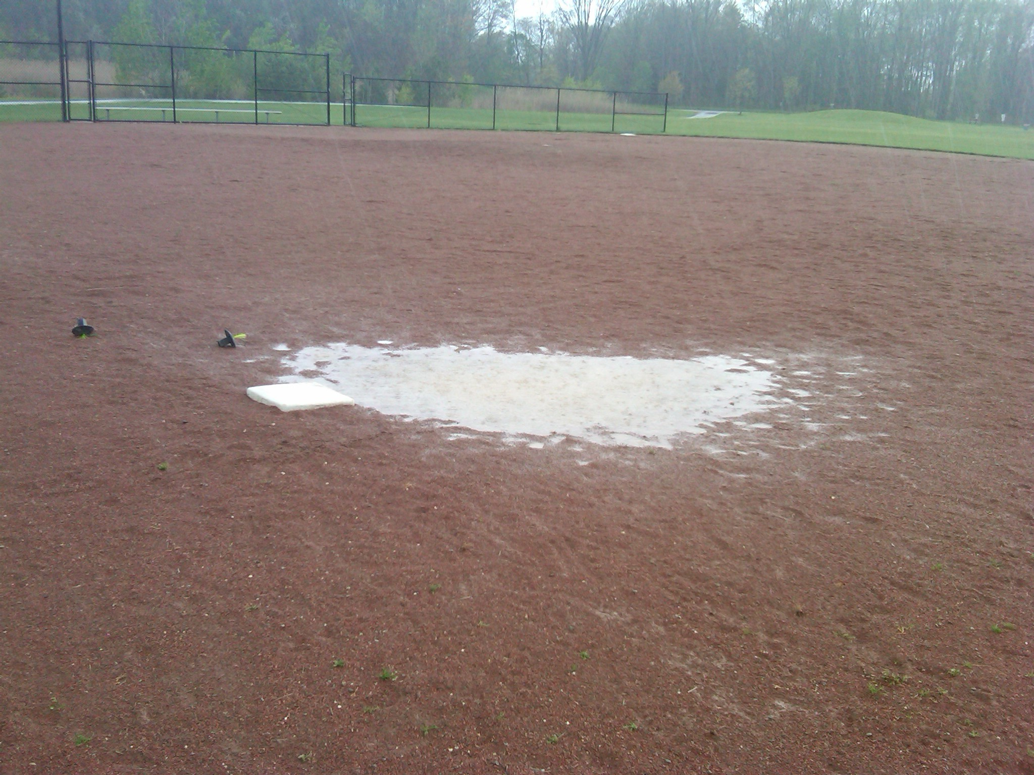
Water can be our friend (if it lightly moistens a dry field) or our enemy if it creates puddles, as in the picture here. You CANNOT simply sweep the water away it will just make more muck and take more time to clean up. As you know, water seeks its lowest point. Simply sweeping it away, you’ll find in 10 minutes it will be back to fill in the lowest spot and you also just pushed more material away making the hole actually deeper. The proper way to remove water is to physically carry it away from the area. First, use a spade to dig a hole about 8” to 12” deep in the lowest spot of the puddle. Leave the fill off to the side, as you will need it again. Start bailing the water out with a plastic glass, bottle or small bucket. Let the puddle stand for about 15 minutes to make sure you get the most water removed. Make sure you dump the water away from the field. While waiting, sprinkle a little field dry on the “fill” you removed (kind of like adding flour to thicken up your dough). When done the hole is dry, refill the hole with the “thickened fill”, work in some “mulemix” (pure clay pellets) with a rake, add a little field dry (Calcite clay), rake some more and then tamp it down with a tamper or the flat end of the rake. I have found that as it starts to dry and be less sticky, driving the tractor tires over the spot several times will help compress the material. Then, you should be good to play. It is okay to delay a game 15 or 30 minutes to get the water off. Playing on a soaked field will only make it more difficult and injuries will happen. If you work too quickly, people will want to play on it as soon as you are done. Working a little slower will give the field a few more minutes to naturally dry.

Base plugs and Dig-out tool
There are many base plugs at each field (either in the sheds or in unused sleeves at different base distances. Please make sure you use the plugs. There are also “dig-out” tools at every field. Please use them to remove any material that has fallen into the base sleeve. The Hollywood style bases will slip in more easily if the sleeve is clear of obstructions.

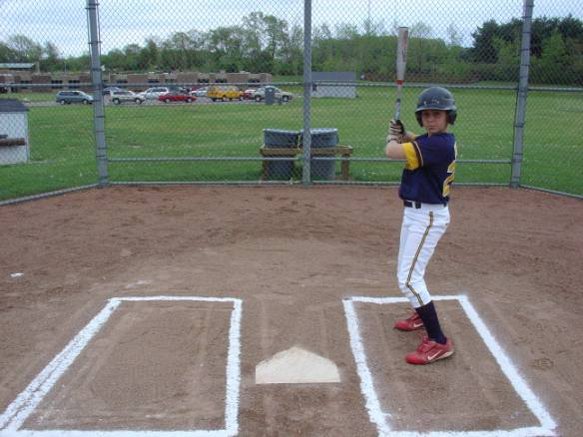
Batters Box
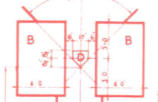
We have PVC templates you can use for your batters boxes. Basically, the templates for the younger kids are 3x5 and for the older kids, 3x6. The boxes are to be 6” off the plate and the center of the box is to match up with the middle of the plate. The best way to ensure the boxes are facing square to the field is to have someone stand on second base as you are aligning the boxes. They’ll have the best view if the box is tilted too much one-way or the other. Not all of our home plates are square (kids sliding into them misaligns them), so don’t use the plate as your reference. Pitchers get messed up if the boxes are tilted and not squared to the field of play.

Foul lines
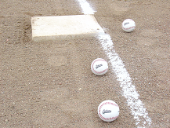
We’ll have the foul lines painted from the grass to the foul pole. You’ll need to chalk the lines. Each shed has a string winder and a pin/nail. Place the nail at the back point of home plate and run your string down the base line (home plate is in fair territory, so the foul line runs from the back point of the plate, along the angled edge of the plate and down the base line). With the base in place, run the string directly next to it, out to the grass. The foul line is to run UNDERNEATH the base, not alongside it. So, as you come down the line with the chalker, drop the chalk to the inside of the string line. Pull the base out temporarily so you can make a continuous line to the grass and then replace the base.

Out of play lines
We’ll have those painted for you.

